Logo%20Main%20200

**Boston University**

**Electrical & Computer Engineering**

**EC463 Capstone Senior Design Project**

**Problem Definition and Requirements Review**

Trivia Throw Toy

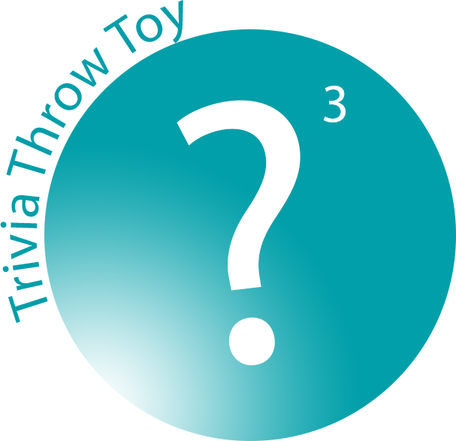

Submitted to

Eugene Kolodenker

eugenek@bu.edu

by

Team #24

Team 3T

Team Members

Jacob Dansey [jdansey@bu.edu](mailto:email1@bu.edu)

Changshuo Fu [fcs1994@bu.edu](mailto:email1@bu.edu)

Christine Low [clow@bu.edu](mailto:email1@bu.edu)

Urvashi Mohnani [umohnani@bu.edu](mailto:email1@bu.edu)

Neil Sanghrajka [neils95@bu.edu](mailto:email5@bu.edu)

Submitted: October 10th, 2016

**Customer Sign-Off _______________________________________**

#### Trivia Throw Toy (3T)

#### Table of Contents

Project Summary………………………………………………………………………………………..3

1 Need for this Project………………………………………………………………………………..4

2 Problem Statement and Deliverables…………………………………………………………….....5

3 Visualization………………………………………………………………………………………...6

4 Competing Technologies…………………………………………………………………………....8

5 Engineering Requirements ………………………………………………………………………....9

6 Appendix A References…………………………………………………………………................12

|  |  |
| --- | --- |
|  | |
|  | |
|  | |
|  | |
|  | |
|  | |
|  | |

# 

# Project Summary

The Trivia Throw Toy is a ball-shaped toy that speaks in a clear voice a trivia fact that has been intelligently parsed from Wikipedia upon detecting it’s been thrown or shaken. The user has the ability to hear facts by category and also up vote/down vote facts to enhance other user’s experience. The interface for picking categories and voting is a mobile application that will talk to the throw toy through Bluetooth. An accelerometer is used within the toy to detect motion. Upon detection, a fact is pulled from the proper categories cache and spoken aloud through a speaker. If the cache is near empty, a call to a cloud server is made to pull more facts in. The server handles the parsing of Wikipedia and identifies proper facts through natural language processing.

# Need for this Project

The rise of personal computing in the 1990's gave birth to a digital revolution. Personal desktops soon evolved into today’s smartphone – a device that allows for a constant connection to the Internet and social media. The distribution rate of smartphones has exploded since 2000 and has brought dramatic change in people’s daily lives. Although smartphone usage has made life more convenient, it has brought about adverse effects in the realms of mental well-being, interpersonal relationships, and physical health [1].

Today’s adolescents are highly receptive to these new forms of media as they are the first generation to be growing up surrounded by this technology. This could mean that youths are more susceptible to the negative effects of smart technology compared to older age groups. In South Korea, smartphone addiction in youths has reached 11.4% of the population [2]. Because of this addiction, many kids are not learning the requisite social skills needed to navigate life. Kids are avoiding confrontational or uncomfortable situations through the haven of the virtual world. The skills developed in these situations are necessary in order to have healthy working and personal relationships.

Parents and teachers need to be aware of the risks associated with smartphone addiction. It is pertinent that kids are brought away from the screen and into interactions with their peers. Obvious solutions, such as not giving them a smartphone, are beneficial but do not take the next step of actively promoting face-to-face engagement. Kids need a fun alternative to their phones in order to engage with their peers on their own accord.

There is a clear and present need for a fun and engaging way to promote conversation. The trivia throw toy aims to fill this need by taking the age-old experience of throwing a ball and adding a trivia twist. The trivia aspect provides educational avenues for conversation that is gamified to maintain interest. This aspect, intertwined with the physical stimulation of throwing a ball, encourages people to connect in more meaningful ways. This tool will be useful as an “ice breaker” or a form of entertainment in office and educational environments or simply around the house with friends. We hope to get people away from the screen and into the real world.

# Problem Statement and Deliverables

We aim to create a working prototype of the Trivia Throw Toy that targets ages of 7 and above. The toy will be in the shape and size of a stress ball so that it is portable and can be easily thrown around. When the user shakes or throws the toy, it will generate and vocalize a random fun fact.

The hardware components include:

* Wifi module - enables the toy to connect to the server to retrieve fun facts that have been parsed from wikipedia and other sources. Will be used to connect the toy to the mobile app as well that will enable the user to pick categories and rate facts.
* Accelerometer - enables the toy to detect changes in motion so that it knows when to generate and say a fun fact.
* Text-to-Speech module - allows the toy to convert the fun fact to speech when vocalized.
* Microprocessor - this component runs a script that connects the toy to the server to retrieve fun facts and says the fun fact when it detects changes in motion.
* Battery - used to power the toy and other hardware modules within it. The battery, aiming for a battery life of 3 hours, will be rechargeable.
* Speaker - used to transmit the fun fact in a clear and audible way.

The software components include:

* Amazon Web Services - remote server that runs a program to parse Wikipedia and other sources for fun facts. The script will also sort the facts based on category and age.
* Natural Language Processing - included in the server’s script to make the fun facts understandable by humans as well as shortening them to about 20 seconds long.
* Caching - used to store facts on the toy so that when wifi is not available the toy can still be thrown around to generate fun facts.
* Alexa API - we aim to make the toy interactive by using the Alexa API so that categories can be picked and facts can be upvoted/downvoted without having to rely on the mobile application.

# Visualization

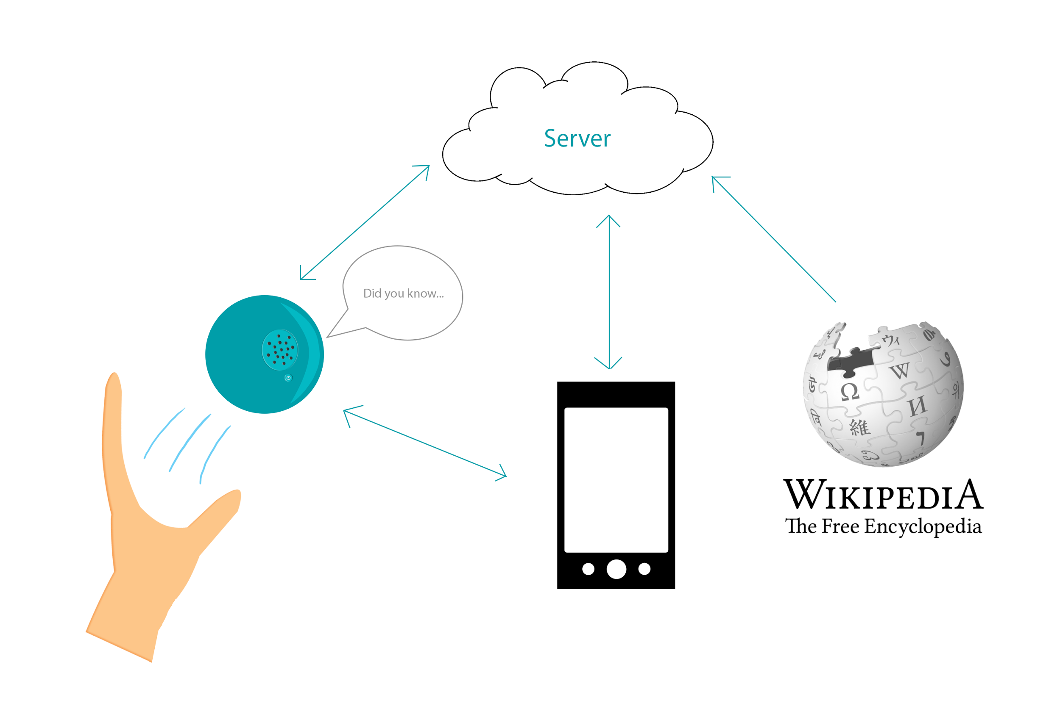

*Figure 1.1 The Trivia Throw Toy will be wifi-enabled in order to interact with the server to fetch fun facts. The server will be responsible for parsing Wikipedia for the facts using natural language processing in order to ensure the facts make sense. The toy will also be able to connect via bluetooth to a smartphone where an app would be used to provide extra functionality and customization to the toy suc h as picking fact categories or upvoting/downvoting facts.*

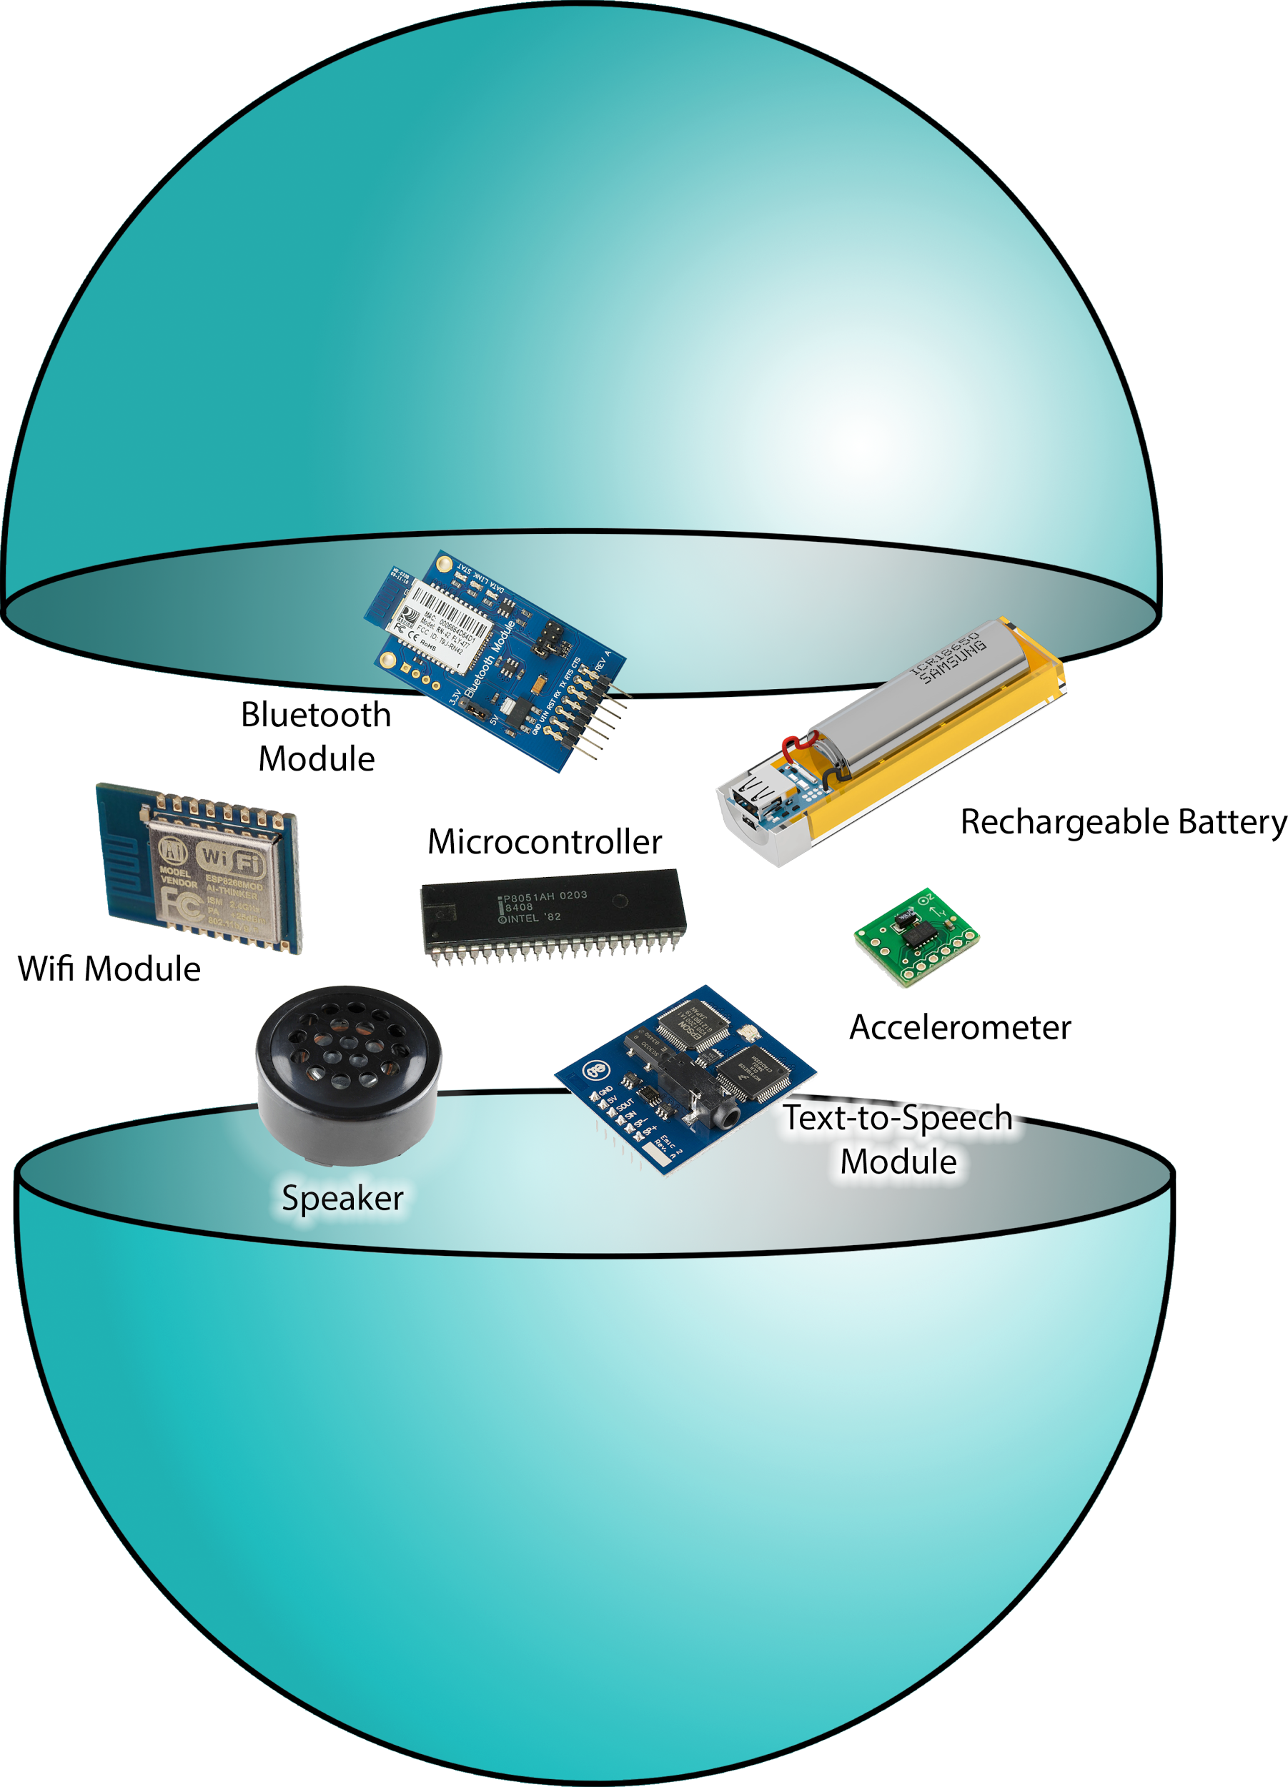

*Figure 1.2 The Trivia Throw Toy consists of a microcontroller, bluetooth module, wifi module, speaker, accelerometer, text-to-speech module and a battery, which will be inside a ball-shaped encasement, allowing it to fit easily into a hand for throwing and catching purposes.*

# Competing Technologies

The competing technologies and products of Trivia Throw Toy can be divided into two kinds: physical and nonphysical.

1. **Nonphysical competing technologies/products:**

Nonphysical competing products are game apps and mobile artificial intelligence (AI). Mobile AI, such as Siri, Google, and Alexa, have the ability to understand the user’s voice commands, such as “Tell me about something interesting” or “Tell me a joke”. The software will then parse the internet for the information and then clearly say it out loud. For game apps, they have the ability to update the newest fun fact and divide them into different categories. These fun facts are provided to the player in engaging ways, like quizzes and short questions. Trivia Crack is a good example of a competing product. It is a mobile game app that provides different trivia questions to the players. Players increase their score if they click the right answer. Trivia Crack also provides the platform for players to compete with each other online. The disadvantages of these nonphysical competing products are obvious: you must have a phone or ipad to use those apps. Everybody is interacting through their phone instead of in person. When people are hanging out with their friends they should interact and talk to each other rather than being on their phones.

**2. Physical competing technologies/products:**

Competing products in the physical realm usually take the form of board games. This type of competing product is suitable for a large amount of people to play at same time, such as Trivia Pursuit. However, there are also disadvantages of this kind of competing technology: The ability to update fun facts with new data is very poor because they are not Wi-Fi enabled. Minimum and maximum player are required and their useful life is not very long.

**3. Advantages of Trivia Throw Toy versus competing technologies:**

The Trivia Throw Toy combines the advantages of physical and nonphysical technologies/products together. An updatable database provides people with the newest interesting things. People can have great fun with it no matter if they are indoors or outdoors, alone or with their friends. The Trivia Throw Toy can also be expanded to have different encasings besides a ball, such as a stuffed animal. This will help appeal to younger age groups as well, without having to worry about a toddler injuring his or herself or trusting the toddler with a phone instead.

# Engineering Requirements

The system designed by the team must fulfill the following high level objectives.

1. When triggered, the toy must say a unique fun fact in an engaging manner.
2. The algorithm must intelligently identify and categorize trivia from a predefined source(Wikipedia).

The following requirements can be used as guidelines to fulfill the objectives of the project.

**Hardware requirements**

1. **Size and Shape:**
   1. The toy must withstand motion: Since the toy is triggered by throwing/shaking it, it must be designed in a manner that the components do not move from their original position.
   2. The toy must be comfortable to hold: The device is coated with stress ball material or a substitute.
   3. The toy must be designed for single hand use: The target size range of the toy is between the size of a baseball and football.
   4. The toy should have the capability to translate to different encasings, such as a stuffed animal, besides a ball, to appeal to different demographics.
2. **Speech**:
   1. The speech must be audible : Controls on the device will allow the volume to be changed from 30-80 decibels. The default will be 60 dB(volume of an average human conversation).
   2. The speech must be clear: An average speed of 140 words per minute must be targeted by the text to speech module on the device.
3. **Battery**
   1. Rechargeable: The batteries on the toy must support charging from any standard 120V and 60Hz AC electricity power outlet
   2. Battery life: The device must support at least 3 hours of continuous usage and indicate to the user when the battery life is under 20%. The toy must automatically shut down when battery <5%.
   3. The toy will be turned on with a switch to preserve battery life when it is not being used. Once the device is charged to >5% battery, it will be able to switch on to be fully functional.
4. **Motion activation**: The toy must be able to detect motion as it is the only way of triggering the toy to say a fact. It must also be able to differentiate between a throw/shake and simply being moved from one position to another.
5. **Connectivity**
6. WiFi: The toy must be able to connect to all public and protected WiFi (802.11a/b/g/n/ac) networks. The wifi module must be able to emit a signal of its own so that the smartphone can connect to the wifi module initially to set up a connection between the toy and the app. Emitting a signal of its own will take away the need of a bluetooth module, reducing the number of modules and the overall cost of the product.

**Software requirements**

1. **Fact retrieval:** 
   1. Instantaneous: The time between the device being triggered and the speech module reading a fact must be less than ½ second.
   2. Minimal reliance on WiFi speed: While internet connectivity is essential to retrieve facts from the server, by caching facts locally on the toy at any given time fact retrieval can be made almost independent of the WiFi speed.
2. **Ability to work offline:** Even without a connection to the server the toy must be useful for at least a small duration of time. At any given time at least 50 facts must be stored locally on the device.
3. **Algorithmic requirements**
   1. Wikipedia crawler: A web crawler must be implemented which is able to extract text from a particular Wikipedia page and automatically identify the Wikipedia page it must parse next.
   2. NLP algorithm: The algorithm must be able to differentiate fun facts from regular sentences and store the facts in a database. It must also be able to restructure sentences so that they are understandable outside the context of that particular Wikipedia page.
4. **Mobile application:** An android application must help the user connect the toy to a particular WiFi network. It should also allow users to select categories for the trivia.
5. **Non repetition of facts:** At no point should a user hear the same trivia again. If all the facts in the database are exhausted the user must be intimated.
6. **Database size:** The initial dataset must contain at least 1000 unique facts. Every time, the algorithm is run it must add new facts to the database, not exceeding 50,000.
7. **Status messages:** The toy must indicate to the user when certain situations occur. This may done using the text to speech module or LEDs. These situations are:
   1. No WiFi connectivity and facts from cache have been exhausted
   2. All facts from database have been exhausted.
   3. Battery critically low (<5%)
   4. Unable to pair with smartphone after searching for >2 minutes.

**Constraints**

1. **Natural Language Processing**: The extent to which the natural language processing is able to determine whether or not a fact is interesting and age appropriate is a limiting factor on the capabilities of the throw toy. It is difficult to distinguish between normal sentences and actual facts of interest.
2. **Connectivity**: The number of facts stored in the cache sets a limit on how long users can play offline. If a user is playing outdoors and the cache runs out, a status message must be displayed alerting the user to connect to WiFi. On the other hand, the cache should be small enough to update regularly with new and better facts. A cache size of 50 should be large enough to support up to three hours of outdoor play.
3. **Battery**: All of the hardware within the ball require a lot of charge. The accelerometer must always be on to detect motion. A high quality speaker is required to ensure outputted sounds are audible and articulate. These features along with the WiFi module puts a strain on the battery life.
4. **Size**: The hardware modules and amount of batteries needed sets a minimum bound on the size of the ball because it all must be able to fit inside. Alternatively, the maximum size of the ball allowed sets a minimum on the amount of space that can be dedicated to hardware and battery.
5. **Volume**: Anything under 30 decibels is mostly inaudible.
6. **Time**: Facts must be under fifteen seconds long because throws are typically under five seconds. Users should not be spending a vast majority of the time waiting for the fun fact to be outputted.

# Appendix A References.

1. Kim, Dongil, Yunhee Lee, Juyoung Lee, JeeEun Karin Nim, and Yeojo Chun. "Development of Korean Smartphone Addiction Proneness Scale for Youth." Public Library of Science. 21 May 2014. Web. 10 Oct. 2016.
2. J, Chen, Yen D, and Chen K. "The Acceptance and Diffusion of the Innovative Smartphone Use." Information and Management (2009): 241-248. Public Library of Science. Web. 10 Oct. 2016.